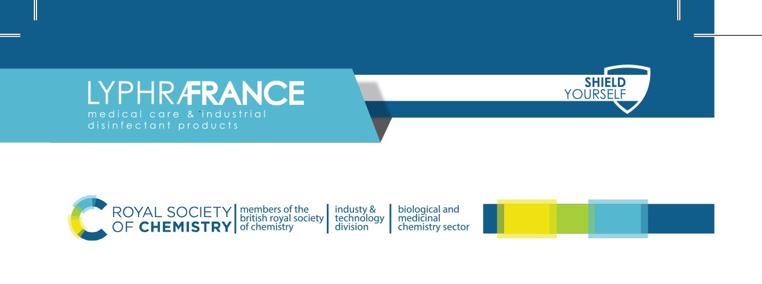
Material Safety Data Sheet
Vacucid
Section 1: Identification of the substance/mixture and of the company/undertaking
Product name: Vacucid
Product Description: Medical suction systems disinfectant.
Instructions for use: Prepare working solution by diluting the concentrate with water.
Dilute 50 ml of the concentrate in 950 ml of water. Introduce solution into suction systems once or twice a day (depending on the level of contamination). Flush suction systems with water to remove the contaminated solution.
Shelf life: 12 months in original packing
Code: V-001
Company: Lyphra-France
Postal address: P.O Box 30-43
Address: Beirut – Lebanon.
Tel: +961 3 065654
Emergency tel: +961 3 248157
Website: www.lyphra-france.com
Email: info@lyphra-france.com
Section 2: Hazards Identification
Main hazard: Eye irritant
Flammability: non-flammable
Biological hazards: none
Reproduction hazards: none
Health effects (eyes): causes irritation
Health effects (skin): irritant
Health effects (inhalation): Not a normal route of exposure. May cause respiratory tract irritation.
Health effects (ingestion): Not a normal route of exposure. May cause stomach distress, nausea, vomiting.
Carcinogenicity: none
Mutagenicity: none
Neurotoxicity: none
Chemical hazard: none
Section 3: Composition
Active ingredient: Alkylpolyglycoside-Trihydroxylphosphine, 1,3- butanediol, C.A.B.M.D, E.T.O.H, dimethyl carbinol and other active ingredients.
Hazardous components: none
Section 4: First aid measures
Product on skin: Flush skin with water. Seek medical attention if irritation develops.
Product inhaled: Remove patient to fresh air and keep at rest in a position comfortable for breathing. If not breathing, give artificial respiration. Seek medical attention immediately.
Product in eye: Flush eye with water thoroughly for 15 minutes. Seek medical attention if irritation persists.
Products ingested: Rinse mouth. Give water to drink if victim is conscious. Call a poison center or physician.
Section 5: Fire Fighting Measures
Extinguishing media: Water fog. Foam, carbon dioxide, dry chemical.
Fire hazards: Product increases the explosive limits, enhances the burning rate and may initiate fire in combustion materials. Combustible materials exposed to product should be immediately submerged in water to ensure that all product is removed. Residual product that is allowed to dry on organic materials such as paper, fabrics, cotton, wood or other combustibles can cause the material to ignite and result in fire.
Advice for firefighters: Wear proper protective equipment including respiratory protection. Exercise caution when fighting any chemical fire. Cool container with water. Prevent fire-fighting water from entering environment.
Section 6: Accidental Release Methods
Personal precautions: Stop leak if safe to do so. Avoid contact with eyes, skin, and clothing. Avoid breathing dust, mist, or spray. Spilled material may present a slipping hazard. Ensure adequate air ventilation.
Environmental precautions: Prevent leakage into drain and into soil. Dispose in a safe manner in accordance with local\national regulations. Ensure all local\national regulations are observed.
Spills: contain and\or absorb spill in a well-ventilated plastic container.
Section 7: Handling and Storage
Suitable storage and\ or handling material: Handle and open container with care.
Storage and\or handling precautions: Keep in original container. Keep container closed in a dry, cool, well-ventilated area. Keep away from sources of heat and direct sunlight.
Section 8: Exposure Controls\ Personnel Protection
Engineering control measures: emergency eye wash fountains should be available in the vicinity of any exposure.
Personnel protection (skin): wear protective clothing, gloves.
Personnel protection (respiratory): in case of insufficient ventilation, wear proper respiratory equipment.
Personnel protection (eyes): wear chemical goggles, safety glasses.
Other protection: none necessary
Section 9: Physical and Chemical Properties
Appearance: clear liquid
Odor: characteristic odor
PH: 10 - 11
Melting point: Not applicable
Flash point: Not applicable
Flammability: non-flammable
Explosive properties: Not applicable
Vapor pressure: Not applicable
Density: 1.07 - 1.11 g\cm³
Neurotoxicity: none
Solubility (water): complete
Solubility (solvents): other alcohols, ether, chloroform
Section 10: Stability and Reactivity
Conditions to avoid: None available.
Incompatible materials: None available.
Hazardous decomposition products: None available.
Section 11: Toxicological Information
Acute toxicity: not classified
Skin and eye contact: refer to section 3
Chronic toxicity: none
Carcinogenicity: none
Mutagenicity: no adverse mutagenic effects indicated
Reproductive hazards: no adverse reproductive effects indicated
Section 12: Ecological Information
Aquatic Toxicity (Fish): Toxic to Fish 16-52 mg\l (exposure time: 96 hours)
Aquatic Toxicity (Daphnia): Toxic to Daphnia at 18-32 mg\l (exposure time: 48 hours)
Aquatic Toxicity (Algae): None
Biodegradability: Yes
Bio-Accumulation: No bio-accumulation indicated
Section 13: Disposal Considerations
Disposal method: Product can be flushed to sanitary sewer, if in accordance with local or national legislations.
Disposal of packaging: Bottle, dispenser, spray pump and/or lid are recyclable
Section 14: Regulatory Information
Specific regulations: Safety out of the reach of children. Keep container closed. Keep away from any source of ignition.
Chemical safety assessment: A chemical safety assessment has not been carried out for the substance or the mixture by the supplier.
Section 15: Other information
Disclaimer: The above information is believed to be correct but does not purport to be all inclusive and shall be used only as a guide. This company shall not be held liable for any damage resulting from handling or from contact with the above product.
Recommended Use: For external use on small surfaces and medical and industrial instruments

